**Experiment 8 : Develop a program to detect the gas leakage in the surrounding environment.**

**Circuit Diagram:**

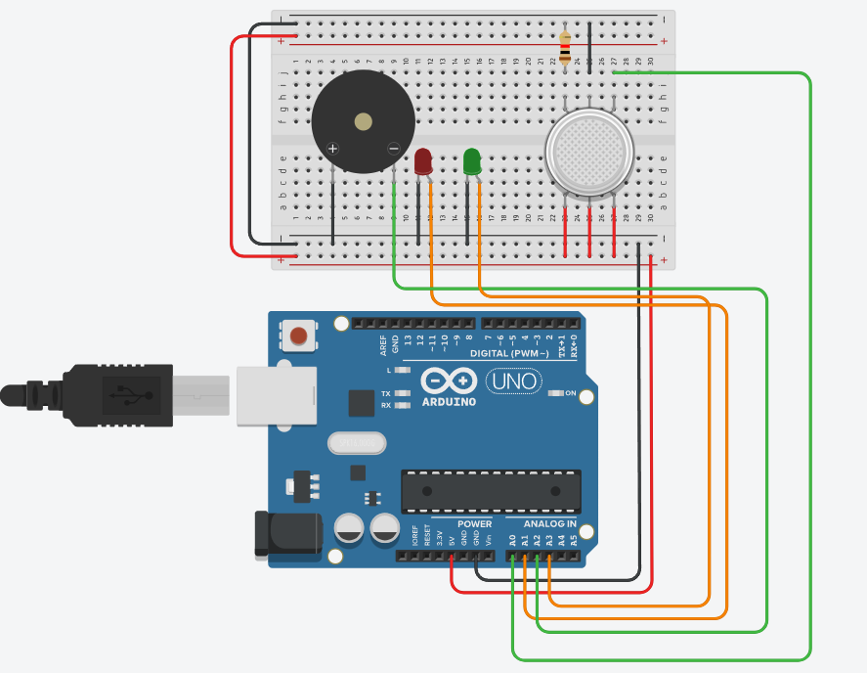

**Code:**

**int LED = A1; //Red LED**

**int LED1 = A3; //Green LED**

**int gas_pin = A0; // For Gas Sensor**

**int buzzer_pin = A2; // For Buzzer**

**void setup()**

**{**

**Serial.begin(9600);**

**pinMode (buzzer_pin, OUTPUT);**

**pinMode (gas_pin, INPUT);**

**pinMode(LED, OUTPUT);**

**pinMode(LED1, OUTPUT);**

**}**

**void loop() {**

**float sensorValue;**

**sensorValue = analogRead(gas_pin); // read analog input pin 0**

**if(sensorValue >= 300)**

**{**

**digitalWrite(LED,HIGH);**

**digitalWrite(LED1,LOW);**

**digitalWrite (buzzer_pin, HIGH);**

**//Serial.println();**

**Serial.print(sensorValue);**

**Serial.println(" |SMOKE DETECTED|");**

**}**

**else**

**{**

**digitalWrite(LED,LOW);**

**digitalWrite(LED1,HIGH);**

**digitalWrite (buzzer_pin, LOW);**

**Serial.println();**

**Serial.println("Sensor Value: ");**

**Serial.print(sensorValue);**

**//Serial.print(" |Safe Mode|");**

**}**

**delay(1000);**

**}**

**Output:**

